
Name___________________________

Maths Specialist - Vectors Investigation 2015
∕45

-------%

The Dot Product

Time: 55 Minutes
Notes permitted
Protractor required

Parallel vectors
1 [1 mark]  Draw two different vectors which are  parallel to vector a.  2 [1 mark]  What is an equal vector? | 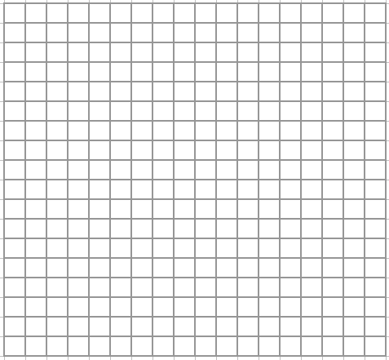  a

Perpendicular vectors
3 [2 marks]
Write in the form < x, y > two different vectors which are perpendicular to vector b,
where b = 2i + 3j

4 [2 marks]
If < m, n > is perpendicular to another vector < c, d >, what observation or relationship
can you observe ?

5 [2 marks]
Identify the following vectors as being either parallel, perpendicular or neither to the
vector < 3, −1 >.

i) < 6, −2 > ii) < −1, 3 > iii) < 2, 6 > iv) < 2, −5 >

The angle between two vectors
The diagram shows the vectors  a = < 5, 12 > and b = < 4, 3 > .  6 [2 marks]  Find ⏐a⏐ and ⏐b⏐, the magnitude of each vector. | b = < 4, 3 >  a = < 5, 12 >  θ

7 [5 marks]
Using conventional trigonometric methods, show that θ = 30⋅51° (correct to 2 dp).

8 [1 mark]
Evaluate ⏐a⏐ x ⏐b⏐ x Cos θ .

The Dot Product

Vector quantities can be “multiplied” in certain ways and the results used in further calculations, some of which do not apply to this course. One calculation that is useful to us is called the Dot Product. The dot product for two vectors a and b originating from the same point is defined as follows:

a . b = ⏐a⏐ x ⏐b⏐ x Cos θ

where θ is the angle formed between the two vectors at the originating point.

Consider the two vectors 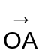 = < −4, −3 > and 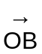 = < −10, 5 > .

9 [2 marks]
Sketch these two vectors on the grid. Clearly label your diagram.

10 [3 marks]
Using a protractor, measure the size of 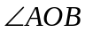, correct to the nearest degree.
Verify the angle size using trigonometry, showing your working for full marks.

11 [2 marks]
Find the dot product . .

12 [2 marks]
Investigate and establish a method for finding the dot product by just using vectors in component form.
That is, . = < −4, −3 > . < −10, 5 >

=

13 [2 marks]
Verify your method works for the vectors mentioned in question 6.

14 [5 marks]
Using vector methods, calculate the size of the angle between the vectors
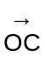 = 3i + 2j and 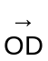 = −4i + 3j .

15 [2 marks]
Referring to earlier work, investigate how the dot product may be used to determine if two vectors are perpendicular. Clearly write down your findings.

16 [6 marks]
Make use of the dot product to prove that the points A (−2, −5), B (6, 2), C (−16, 11) form a right angled triangle. Show full working.

17 [5 marks]
Make use of the dot product to calculate the size of ∠ ABC correct to one decimal place.
Show full working.

A (5, 8)
B (0, 0)
C (10, 3)

END OF INVESTIGATION
Vectors Investigation – The Dot Product

45 Marks 55 Minutes SOLUTIONS
Notes permitted protractor required

Parallel vectors
1 [1 mark]  Draw two different vectors which are  parallel to vector a.  2 [1 mark]  What is an equal vector ?  An equal vector has the same magnitude and direction.  |   a

Perpendicular vectors
3 [2 marks]
Write in the form < x, y > two different vectors which are perpendicular to vector b,
where b = 2i + 3j

c = < 3, –2 > and d = < –3, 2 > are just two examples.
           

4 [2 marks]
If < m, n > is perpendicular to another vector < c, d >, what observation or relationship
can you observe ?

That m x c + n x d = 0 or an equivalent statement. 

5 [2 marks]
Identify the following vectors as being either parallel, perpendicular or neither to the
vector < 3, −1 >.

i) < 6, −2 > ii) < −1, 3 > iii) < 2, 6 > iv) < 2, −5 >

Parallel Neither Perpendicular Neither

The angle between two vectors
The diagram shows the vectors  a = < 5, 12 > and b = < 4, 3 > .  6 [2 marks]  Find ⏐a⏐ and ⏐b⏐, the magnitude of each vector.  ⏐a⏐ = 13   ⏐b⏐ = 5  | b = < 4, 3 >  a = < 5, 12 >  θ

7 [5 marks]
Using conventional trigonometric methods, show that θ = 30⋅51° (correct to 2 dp).

Vector c representing the third side of the triangle, c = < 1, 9 >. 

⏐c⏐ = 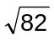 

cos θ = 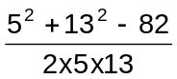  

θ = 30∙51º as required 

8 [1 mark]
Evaluate ⏐a⏐ x ⏐b⏐ x Cos θ .

⏐a⏐ x ⏐b⏐ x Cos θ = 5 x 13 x 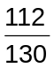
= 56 

The Dot Product

Vector quantities can be “multiplied” in certain ways and the results used in further calculations, some of which do not apply to this course. One calculation that is useful to us is called the Dot Product. The dot product for two vectors a and b originating from the same point is defined as follows:

a . b = ⏐a⏐ x ⏐b⏐ x Cos θ

where θ is the angle formed between the two vectors at the originating point.

Consider the two vectors = < −4, −3 > and = < −10, 5 > .

9 [1 mark]
Sketch these two vectors on the grid. Clearly label your diagram.

 
O
B
A

10 [4 marks]
Using a protractor, measure s, correct to the nearest degree.
Verify the angle size using trigonometry, showing your working for full marks.

One mark for measuring the angle 

|c| = 10 
cos θ = 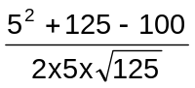      ( cos θ = 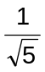 )

θ = 63º as required 

11 [2 marks]
Find the dot product . .

⏐a⏐ x ⏐b⏐ x Cos θ = 5 x 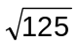x 
= 25 

12 [2 marks]
Investigate and establish a method for finding the dot product by just using vectors in component form.
That is, . = < −4, −3 > . < −10, 5 >

= –4 x (–10) + (–3) x 5 

= 25 

13 [2 marks]
Verify your method works for the vectors mentioned in question 6.
. = <5, 12 > . < 4, 3 >

= 5 x 4 + 12 x 3 

= 56 

14 [5 marks]
Using vector methods, calculate the size of the angle between the vectors
= 3i + 2j and = −4i + 3j .

. = <3, 2 > . < –4, 3 >

= –6 

|| = 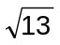 and || = 5 

Now || x || x cos θ = –6 

cos θ = 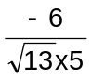 

θ = 109∙44º  

15 [2 marks]
Referring to earlier work, investigate how the dot product may be used to determine if two vectors are perpendicular. Clearly write down your findings.

Perpendicular means at 90º and cos 90º = 0

Therefore if ⏐a⏐ x ⏐b⏐x Cos θ = 0 then θ = 90º .

i.e. the two vectors would be perpendicular to each other. 

So if the dot product is 0 then vectors are perpendicular . 
16 [6 marks]
Make use of the dot product to prove that the points A (−2, −5) , B (6, 2) , C (−16, 11) form a right angled triangle. Show full working.

⏐a⏐ = | < 6 + 16, 2 – 11 > | = 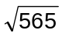
⏐b⏐ = | < –2 + 16, –5 – 11 > | = 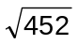
⏐c⏐ = | < –2 – 6, –5 – 2 > | = 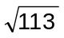 longest side, a, opposite the right angle. 
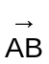 = < 8, 7 > and 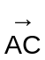 = < –14, 16 >   
. = 8 x (–14) + 7 x 16

= –112 + 112

= 0 
∴ is perpendicular to , right angle at A.

∴ Triangle ABC is a right angled triangle. 

17 [5 marks]
Make use of the dot product to calculate s∠ ABC correct to one decimal place.
Show full working.

A (5, 8)
B (0, 0)
C (10, 3)

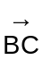 = < 10, 3 > and 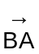 = < 5, 8 > 
|| = 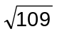 and || = 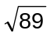  

cos θ = 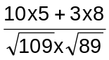 

θ = 41∙3º 

